Creating new forms.
The toolbar guides you to the creation.

The first left icon will open an existing file and maintain data.

Alignment when creating dataforms

action | entry field | label
Mouse click: default | placed at x,y by mouse position | in front of field right aligned
Add structure: | placed one by one below last field on form aligned by left sides | in front of field right aligned
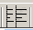
By clicking on the alignment tab
You have the option of automatically rearranging the fields and labels:

Default Alignment: fields placed in a single column.
If any fields are placed next to each other they are moved to a single column
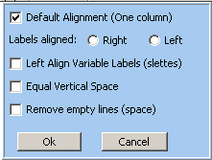
Label alignment: “sticky” to fields (right aligned)
left: aligned by longest label

⁻Space btw. fields divided equally among all fields, labels placed according to “align Variable Labels text”

remove all empty lines, labels unchanged

